Insert Practice letterhead or logo here

The FreeStyle Libre 2 system Invitation Letter
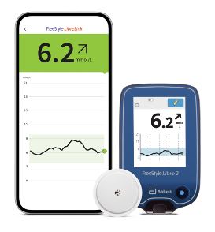
Dear Patient,
You have been identified as being eligible for the NHS funded FreeStyle Libre 2 system to help self-manage your diabetes and replace routine finger prick testing¹.
If you want to know more about the FreeStyle Libre 2 system, you can watch a short 2-minute video here https://youtu.be/x-pOZNkXLgw

Important - What you need to do next
Please complete the simple steps below to order your starter kit and complete online training. If you are unable to do this and need to be trained in person, please contact your GP practice.
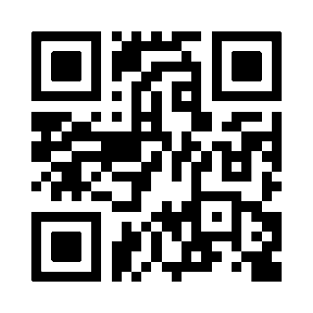
Step 1 -Simply scan the QR code or click this link freestylediabetes.co.uk/starterclinic/starter-letter-order to order your FreeStyle Libre 2 starter kit (free of charge).
Step 2 - You will receive an email with a link to our online training video. Please watch the video and download your completion certificate.

Once you have completed the training, you may need to inform your GP practice to request ongoing supply of FreeStyle Libre 2 sensors are added to your repeat prescription.
Important Information: If you start your FreeStyle Libre 2 sensor with your FreeStyle Libre 2 reader you will not receive real-time glucose readings, even if you use the updated FreeStyle LibreLink app as your second device. You will need to scan to get your glucose reading on both devices. Glucose alarms are only received on the device used to start the sensor.
Kind regards
Insert GP surgery name and contact telephone number

Optional - To connect and share your glucose data with the practice - Open FreeStyle LibreLink App* > Menu > Connected Apps > LibreView (connect) > Connect to a Practice > Enter Practice ID (insert practice ID)
Abbott Customer Care Team (product manufacture)
General enquiries: 0800 170 1177 (Mon-Fri 8:00am – 8:00pm, Sat 9:00am – 5:00pm)
Digital Health Solutions (FreeStyle LibreLink, LibreLinkUp and LibreView): 0800 612 3006 (Mon-Fri 8:00am – 5:30pm)
Product image is for illustrative purposes only. Not real patient or data.
1. Finger pricks are required if your glucose readings and alarms do not match symptoms or expectations. *The FreeStyle LibreLink app is only compatible with certain mobile devices and operating systems. Please check the website for more information about device compatibility before using the app. Sharing glucose data requires registration with LibreView.

