Insert Practice letterhead or logo here

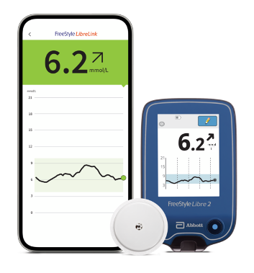
The FreeStyle Libre 2 system Invitation Letter
Dear Patient,
You have been identified as being eligible for the NHS funded FreeStyle Libre 2 system to help self-manage your diabetes and replace routine finger prick testing¹.
If you want to know more about the system, you can watch a short 2-minute video here https://youtu.be/x-pOZNkXLgw

Important - What you need to do next…
We would like to invite you to be trained and started on the FreeStyle Libre 2 system in a face-to-face clinic. Please attend the training event as detailed below. If you are unable to attend, please contact your GP practice to organise an alternative date.
Insert time, date, and location
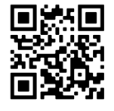
In advance of attending your training, please download the FreeStyle LibreLink* app from the Apple App Store or Google Play using the QR code. If you don’t have a smartphone, you will be offered a free of charge FreeStyle Libre 2 reader◊ as part of your training.

Kind regards
Insert GP surgery name and contact telephone number

Optional - To connect and share your glucose data with the practice - Open FreeStyle LibreLink App > Menu > Connected Apps > LibreView (connect) > Connect to a Practice > Enter Practice ID (insert practice ID)
For FreeStyle Libre 2 reader◊ users - Visit www.LibreView.com to sign up/sign in > Click on the three little lines in the top right of the screen > Account Settings > My Practices > Enter Practice ID (insert) and click on Add.
Abbott Customer Care Team (product manufacture)
General enquiries: 0800 170 1177 (Mon-Fri 8:00am – 8:00pm, Sat 9:00am – 5:00pm)
Digital Health Solutions (FreeStyle LibreLink, LibreLinkUp and LibreView): 0800 612 3006 (Mon-Fri 8:00am – 5:30pm)
Product image is for illustrative purposes only. Not real patient or data.
1. Finger pricks are required if your glucose readings and alarms do not match symptoms or expectations. *The FreeStyle LibreLink app is only compatible with certain mobile devices and operating systems. Please check the website for more information about device compatibility before using the app. Use of FreeStyle LibreLink may require registration with LibreView. ◊ Patients choose which device they want to receive alarms: FreeStyle Libre 2 reader or FreeStyle LibreLink app. They must start their FreeStyle Libre 2 sensor with that selected device. Once the patient scans their FreeStyle Libre 2 sensor with that device, they can receive alarms only on that device. The FreeStyle LibreLink app and FreeStyle Libre 2 reader do not share data with each other and you will need to scan both devices to get your glucose readings.

