Invitation to benefit from Flash glucose monitoring technology
Dear (Patient Name)
You have been identified as being eligible to start the FreeStyle Libre 2 flash glucose monitoring system to help self-manage your diabetes and replace routine finger prick testing¹. Please follow the steps below to complete the training process, however if you are unable to do this online, please contact your GP practice.
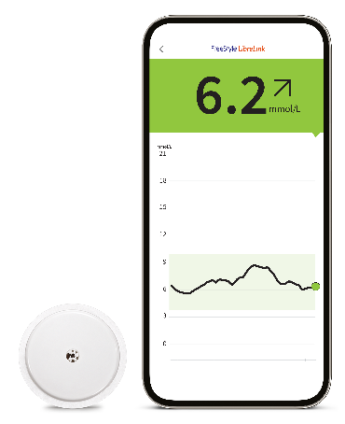
What is the FreeStyle Libre 2 system?
The FreeStyle Libre 2 system allows patients to manage their glucose levels without the need for finger prick testing^{1,2,5}, and is proven to decrease HbA1c in people with Type 1 diabetes³ and Type 2 diabetes using insulin⁴.
- Easy to wear⁵ - The sensor is small, water-resistant⁶, and can be easily applied to the back of the upper arm and lasts up to 14 days
- Easy to scan⁵ - All it takes is a quick 1-second scan over clothes⁸ to monitor glucose conveniently anytime⁷ and anywhere⁶
- Easy to understand – FreeStyle Libre 2 system users find it easier to interpret results compared to other CGMs^{10,11}

What do I need to do?
Step 1. Order your starter kit - Please visit the following link freestylediabetes.co.uk/starterclinic/starter-letter-order or access via the QR code below whereby you will be asked to complete a sample request form, as well as download the FreeStyle LibreLink app⁹ to scan your sensor with. Once the sample request has been submitted, the FreeStyle Libre 2 system starter kit will be delivered to the address you specified (delivery may take up to 7 working days).
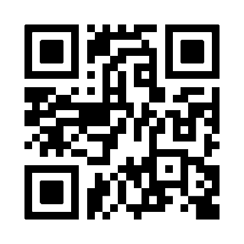

Please note: As part of the instructions for FreeStyle Libre 2 sensor application you will require alcohol wipes. Alcohol wipes are not provided in the sensor kit but are readily available at minimal cost from pharmacies and other retailers.

Step 2. Complete your training - When your sample arrives or before applying your sensor for the first time, please click on the following link FreeStyleDiabetes.co.uk/FSL2start or access via the QR code below to watch the FreeStyle Libre 2 starter clinic training video. This takes a little over an hour and will explain how the FreeStyle Libre 2 system works, how to apply new sensors as well as other helpful information. After watching the training video, please contact your GP practice to process your prescription for the FreeStyle Libre 2 sensors.
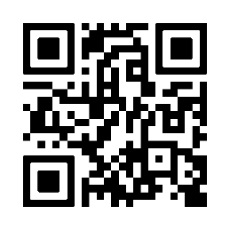
Step 3. Proof of training and request for ongoing prescribing of sensors – Insert details/instructions here you wish for patients to share the training certificate with the team to organise repeat prescribing of sensors. Delete this step if not needed.

Step 4. Please connect and share your glucose data with (insert name of GP practice LibreView) by following the simple instructions below;
App/phone users⁹: Open FreeStyle LibreLink App > Menu > Connected Apps > LibreView (connect) > Connect to a Practice > Enter Practice ID (insert)
FreeStyle Libre 2 reader users◊ - Visit www.LibreView.com to sign up/sign in > Click on the three little lines in the top right of the screen > Account Settings > My Practices > Enter Practice ID (insert) and click on Add. Users need to upload their glucose data from the reader to LibreView once every 90 days

Kind regards
(Insert GP Surgery name and contact telephone number)

Additional information can be found below:
https://progress.freestylediabetes.co.uk/ - FreeStyle Academy training modules
https://www.freestylediabetes.co.uk - Patient oriented site full of information and videos to get you up and running with the sensor and digital health solutions

Abbott Customer Services:
General enquiries:
0800 170 1177 (Mon-Fri 8:00am – 8:00pm, Sat 9:00am – 5:00pm)
Digital Health Solutions (FreeStyle LibreLink):
0800 612 3006 (Mon-Fri 8:00am – 5:30pm)

