Invitation to benefit from Flash glucose monitoring technology
Dear (Patient Name)
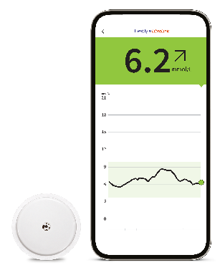
You have been identified as being eligible to start the FreeStyle Libre 2 flash glucose monitoring system to help self-manage your diabetes and replace routine finger prick testing¹.
What is the FreeStyle Libre 2 system?
The FreeStyle Libre 2 system allows patients to manage their glucose levels without the need for finger prick testing^{1,2,5}, and is proven to decrease HbA1c in people with Type 1 diabetes³ and Type 2 diabetes using insulin⁴.
- Easy to wear⁵ - The sensor is small, water-resistant⁶, and can be easily applied to the back of the upper arm and lasts up to 14 days⁷
- Easy to scan⁵ - All it takes is a quick 1-second scan over clothes⁸ to monitor glucose conveniently anytime⁷ and anywhere⁶
- Easy to understand - FreeStyle Libre 2 system users find it easier to interpret results compared to other CGMs^{9,10}

What do I need to do? - GP practice to edit accordingly and use either option A or B
- Please attend (insert practice name and address, or training location) at (insert time and date) to receive your FreeStyle Libre 2 training.
- Please book an appointment with the GP surgery by contacting (insert practice contact details) to start your FreeStyle Libre 2 journey.
In advance of attending your training, please download the FreeStyle LibreLink* app from the Apple App Store or Google Play using the QR code below. If you don’t have a smartphone, you will be offered a free of charge FreeStyle Libre 2 reader as part of your training.
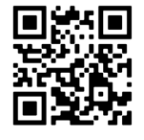
Please connect and share your glucose data with (insert name of GP practice LibreView) by following the simple instructions below;
FreeStyle LibreLink* app/phone users: Open FreeStyle LibreLink App > Menu > Connected Apps > LibreView (connect) > Connect to a Practice > Enter Practice ID (insert)
FreeStyle Libre 2 reader users◊ - Visit www.LibreView.com to sign up/sign in > Click on the three little lines in the top right of the screen > Account Settings > My Practices > Enter Practice ID (insert) and click on Add. Users need to upload their glucose data from the reader to LibreView once every 90 days
Kind regards
(Insert GP Surgery name and contact telephone number)

Additional information can be found below:
https://progress.freestylediabetes.co.uk/ - FreeStyle Academy training modules
https://www.freestylediabetes.co.uk - Patient oriented site full of information and videos to get you up and running with the sensor and digital health solutions

Abbott Customer Services:
General enquiries:
0800 170 1177 (Mon-Fri 8:00am – 8:00pm, Sat 9:00am – 5:00pm)
Digital Health Solutions (FreeStyle LibreLink):
0800 612 3006 (Mon-Fri 8:00am – 5:30pm)

